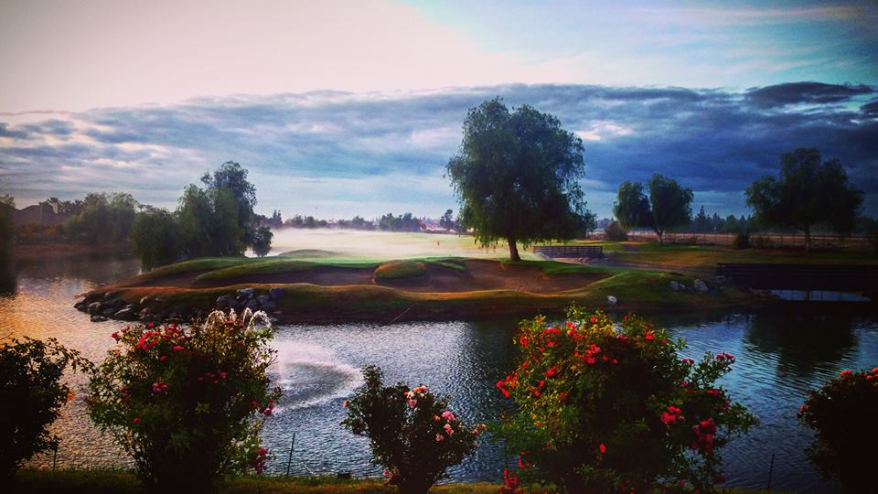

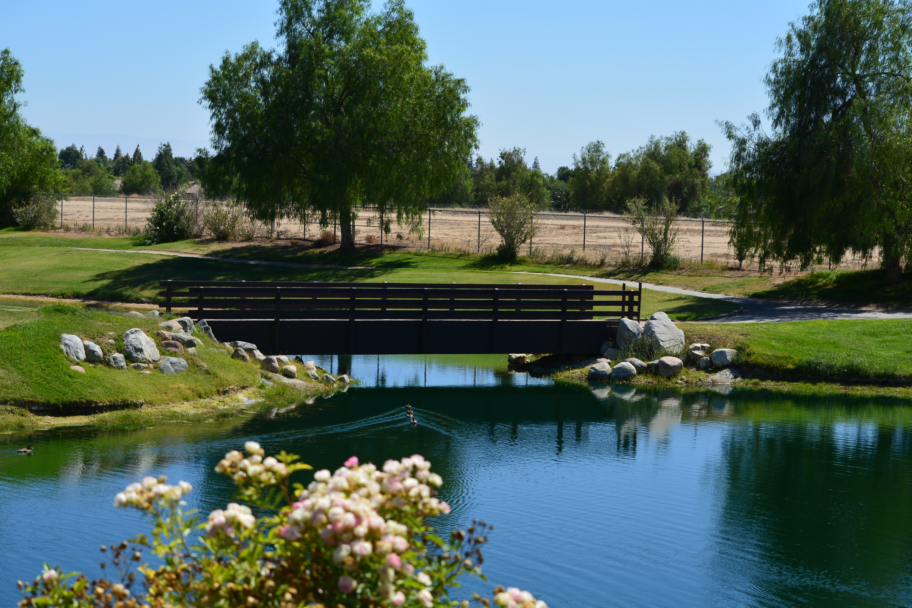
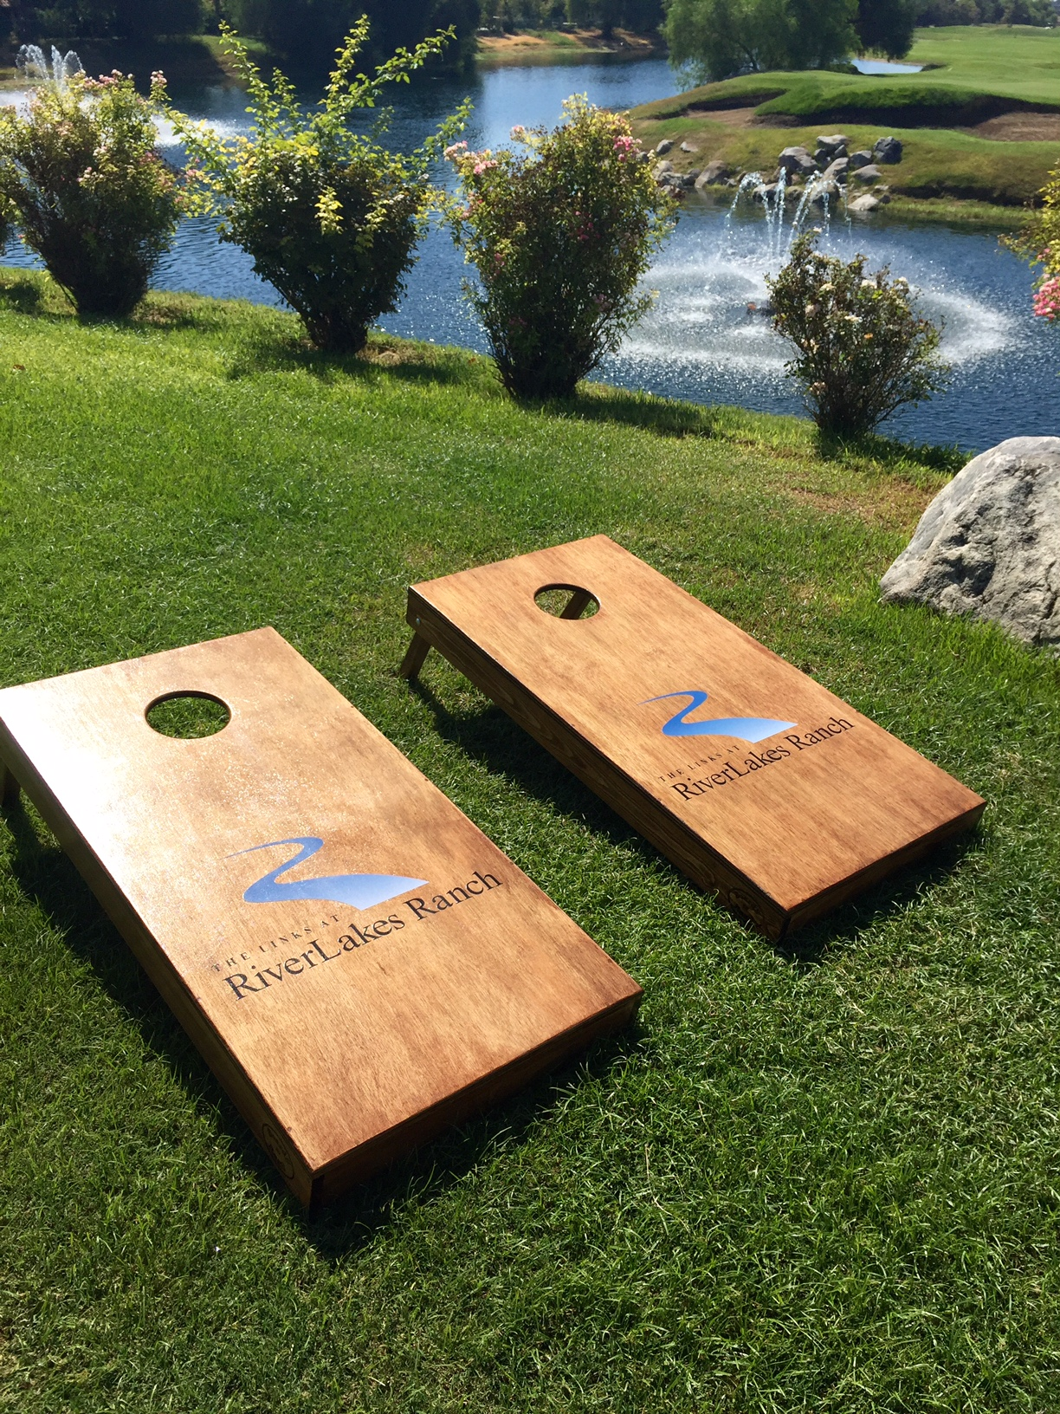
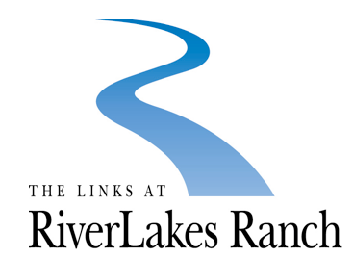
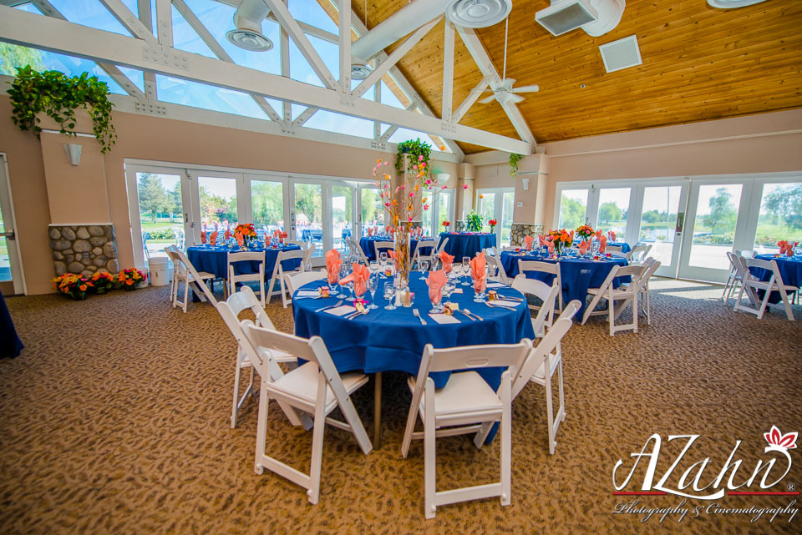
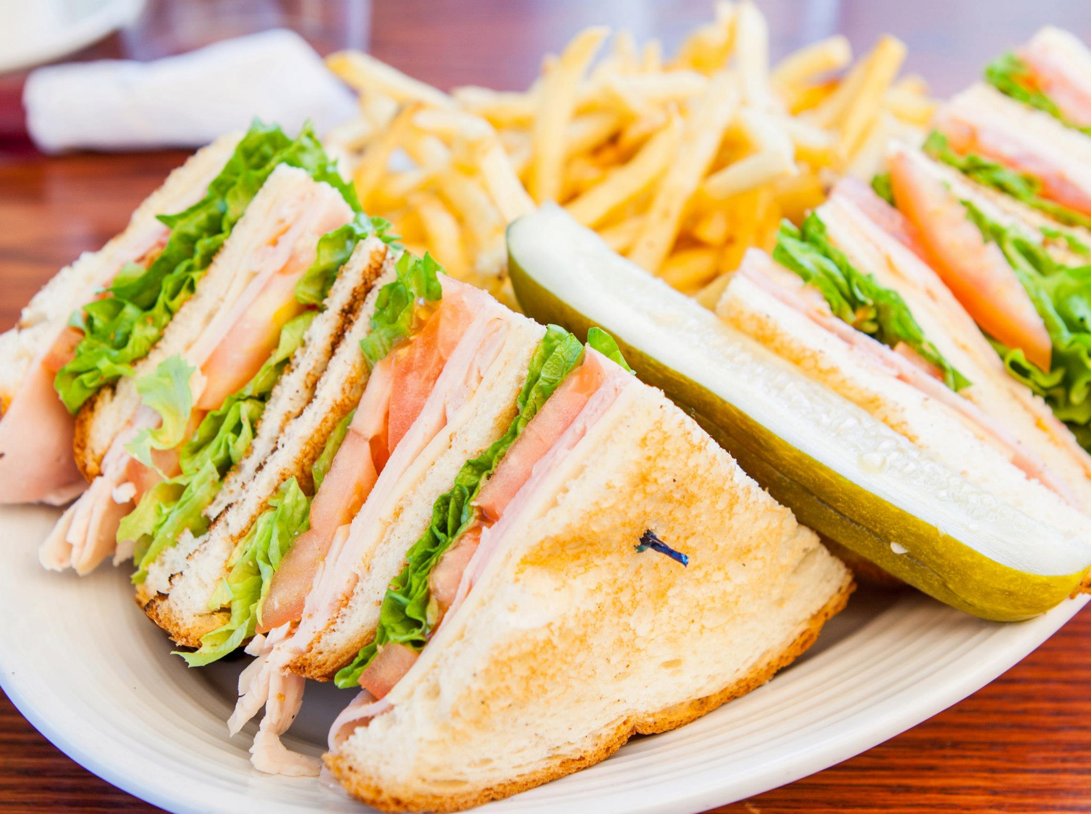


The Staff at RiverLakes Ranch
Take a well-deserved break during your meeting and play a friendly game of Cornhole on the back patio.
The Links at RiverLakes Ranch provides a comfortable offsite venue for a meeting or luncheon. A change of scenery can often make the difference in improving business and personal relationships.
Our private room provides a scenic view of the golf course, lakes, and fountains and can accommodate groups of 12 to over 150.
We offer Country Club service, facilities, and ambiance without the stuffy attitude or price that goes with it. Whatever your needs, we will customize, accommodate, and provide the best value in Bakersfield!
Come see for yourself!
To arrange your club visit contact one of our event planners today at 661-587-5465!

Host your next Company Meeting with us…

The Links at RiverLakes Ranch

Business Packages
  - 5201 Riverlakes Dr., Bakersfield, Ca, 93312 | 661.587.5465

Sincerely,
Our banquet room is available Monday – Sunday. Breakfast and Lunch Packages include room set up, linens, iced tea, and water. Please call one of our event coordinators today for more information, and don’t forget to ask about including a golf outing!
Give us a call at 661-587-5465!

What’s Included?
Starting at $7 per person our delicious continental breakfast includes coffee, orange juice, and an assortment of fresh danishes, croissants, and muffins.
Starting at $15 per person our breakfast buffet includes orange juice, coffee, scrambled eggs, country potatoes, bacon, sausage, and biscuits and gravy.

Continental Breakfast &

Breakfast Buffet
Starting at $15 per person our Taco Bar includes everything a Taco Lover would want. Your choice of meats with all the dressings: lettuce, tomato, fresh onion, salsa, cheese, sour cream and more!

Menu Items
Order any item from our delicious menu. Starting at $15 per person, this option is the best if you have picky eaters. Choose from one of our signature salads, sandwiches or gourmet burgers.

Taco Bar

